Australian Alpine Club (Dinner Plain) Cooperative Limited
G0002509Y registered 30/01/1985, ABN 44 279 308 041
58 Vincent Street, Glen Iris Vic. 3146, Australia

All members and adult guests booked into the AAC Dinner Plain lodge must read and sign the following “AAC Dinner Plain COVID 19 Declaration” prior to arrival.
The signed form or email declaration should be returned to booking@aacdinnerplain.com.au

AAC Dinner Plain COVID 19 Declaration

- The Australian Alpine (Dinner Plain) Cooperative Limited (the “Cooperative”) has put in place a number of preventative measures to reduce the spread of COVID-19. However, the Cooperative cannot guarantee that you or anyone else attending the Cooperative premises (the “Lodge”) will not become infected with COVID-19. Further, attending the Lodge could increase your risk of contracting COVID-19.

- The Cooperative has adopted a COVID Safe Plan based on the current Victorian Government guidelines for the Tourism Industry and the Hospitality Industry. You must familiarise yourself with this document and comply with it at all applicable times. You must also comply with any direction from the Lodge Managers and/or any other representative of the Board of the Cooperative. You can familiarise yourself with the AAC Dinner Plain COVID Safe Plan at:
- AAC Dinner Plain Lodge COVID Safe Plan

- You must comply with all Federal, State and Local Government requirements and guidelines, including the requirement to remain at a distance of 1.5 metres from any other individual.

- You are responsible for ensuring that all children and minors for whom you are responsible comply with all COVID-19 requirements.

- Any breach or non-compliance with any COVID-19 requirements may lead to a direction being issued to you by the Lodge Managers and/or any other representative of the Board of the Cooperative to immediately leave the premises. If such a direction is issued, you must comply with it. Failure to comply with such a direction may also lead to expulsion of the booking member pursuant to Section 9 of the Rules of the Cooperative.

- By signing this form,you agree to the above conditions and you also acknowledge the contagious nature of COVID-19. You voluntarily assume the risk that you, your children or other minors for whom you are responsible, may be exposed to or affected by COVID-19 by attending the Lodge and that such exposure or infection may result in personal injury, illness, permanent disability or death. You further understand that the risk of becoming exposed or infected by COVID-19 at the Lodge may result from the actions, omissions or negligence of yourself or others including but not limited to Cooperative employees and volunteers.

- You voluntarily agree to assume all of the foregoing risks and to accept the sole responsibility for any injury to you which you or your children or other minors for whom you are responsible may experience or incur in connection with attendance at the Lodge. You hereby release, discharge and hold harmless the Cooperative, its Directors, employees, agents and representatives of and from any claims including all liabilities, claims, actions, damages, costs or expenses of any kind arising out of or relating thereto. You understand and agree that this release includes any claims based on acts, omissions or negligence of the Cooperative, its Directors, employees, agents and representatives whether the COVID-19 infection occurs before, during or after your attendance at the Lodge.

- You further agree that if you, your children or other minors for whom you are responsible display any flu like symptoms whilst staying at the Lodge, you must immediately notify the Lodge Managers and/or any other representative of the Board of the Cooperative and immediately retire to your allocated room. In the event that you develop a fever (i.e. if your body temperature increases to 38°C or in the case of children o 37.5°C) you will be required to vacate the lodge as soon as reasonably practicable. You are required to notify the Lodge Managers and/or any other representative of the Board of the Cooperative in the event that a subsequent COVID 19 test is returned positive.

- You agree that in the event that you, your children or other minors for whom you are responsible display any flu like symptoms in the 14 days prior to the first day of the booking, you will only take up your booking after a negative test for COVID 19 has been returned.

If responsible for any minors whilst at the lodge please provide names.
NAMES OF YOUR CHILDREN AND/OR ANY MINORS FOR WHOM YOU ARE RESPONSIBLE
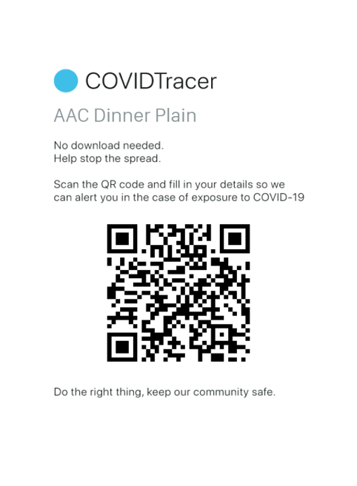

By scanning the QR code and completing the contact details you agree to this waiver
Or you may complete and send the following information to booking@aacdinnerplain.com.au)
Email Declaration
I have read and agree with the “AAC Dinner Plain COVID 19 Declaration”.
My name:
My contact phone number:
My email address:

